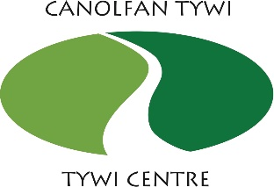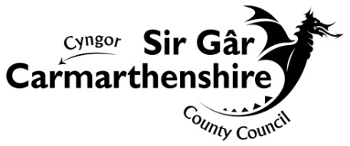

**How we use your information**

**Privacy notice for Canolfan Tywi Centre**

The proper handling of personal information by Carmarthenshire County Council is very important to the delivery of our services and maintaining public confidence.

Personal data is any information that relates to a person who can be directly or indirectly identified from the information. The terms ‘information’ and ‘personal data’ are used throughout this privacy notice and have the same meaning.

To ensure that the Council treats personal information correctly, we seek to adhere in full to the requirements of Data Protection legislation.

This privacy notice has therefore been produced to explain as clearly as possible what we do with your personal data.

**1. The purposes for which we use your personal data:**

**The Specialist Applied-skills Programme (SAP)**

The information we collect about you will be used to:

* Check eligibility for courses funded by the Construction Industry Training Board
* Register individuals on the NVQ3 Heritage course
* Keep in contact with students and employers during the training and once this has been completed

**External contractors**

The information we collect about you will be used to make payments and for auditing purposes.

**Mailing list/ short courses/ conferences**

The information we collect about you will be used to register you on short training courses and provide you with up-dates on training and events relating to Built Heritage.

**2 . What type of information do we use?**

We collect the following types of personal data about you:

* Name
* Contact details
* Date of birth

If you are an external contractor, we also collect and use bank/payment details.

If you are an SAP student, we need to process more personal data. This is comprised of:

* Your National Insurance Number
* Unique learner number
* CSCS Card number
* Employment and education details
* Your racial or ethnic origin, gender and whether you have a disability, which is only used for equal opportunities monitoring

The legal basis for the processing of your information is to exercise our official authority or to perform a specific task in the public interest that it is set out in law, namely the Local Government Act 1972 and the Local Government Act 2000.

We process special category personal data needed for equal opportunities monitoring on the basis of substantial public interest.

**3. Do we use information received from other sources?**

To deliver this service, we only collect personal data directly from you and do not obtain information about you from any other source.

**4. Transferring your information abroad**

Your information will not be transferred outside the United Kingdom.

**5. Who has access to your information?**

We only share personal data where this is necessary and provide the minimum required in each case.

**SAP students:**

We share your information with the following recipients:

* The Construction Industry Training Board - this includes equal opportunities monitoring information.
* Your allocated Assessor for the NVQ3 Heritage Course

**External contractors**

We share your information with the Council’s Finance team to make payments as well as Audit Officers and Grant Providers.

There are also other specific situations where we may be required to disclose information about you, such as:

* Where the Council is required to provide the information by law
* Where disclosing the information is required to prevent or detect a crime
* Where disclosure is in the vital interests of the person concerned

**6. How long we will keep your information**

We will keep your information for 6 years after the completion of your training course. We keep financial information regarding external contractors for six years from the end of the financial year.

**7. Your Data Protection rights**

You have the right to:

* Obtain access to the personal data that Carmarthenshire Council is processing about you – you can do this by making a request using the contact details provided below
* Have any inaccurate or incomplete information rectified (corrected)
* Withdraw your consent to processing, where this is the only basis for the processing
* Make a complaint to the Information Commissioner’s Office (ICO), the independent body in the UK which protects information rights

In some circumstances, you may have the right to:

* Object to the processing of your personal information
* The erasure of your personal data
* Restrict the processing of your personal information
* Data portability

**8. Contact details**

For more information regarding this privacy notice and your rights, please contact:

Data Protection Officer

Carmarthenshire County Council

County Hall

Carmarthen

SA31 1JP

Email: [dataprotection@carmarthenshire.gov.uk](mailto:dataprotection@carmarthenshire.gov.uk)

Tel: 01267 224127

Contact details for the Information Commissioner’s Office along with further guidance on Data Protection legislation can be found on the ICO website:

[www.ico.org.uk](http://www.ico.org.uk)